NAME : PUTERA MUHAMMAD SYABIL BIN SARIANTO

KHOO JIE XUAN

PHARVEISH A/L SELVAM

LAB 5

EXERCISE 1

1 a) True

b)False : studentName = “Safiyyah”;

c)True

d)False : subject = “Software Engineering”

e)False : string university = “UTM”;

2 a) string vehicle;

b)string student1;

string student2;

student1= student2;

c)string city=”Pasir Gudang”;

d)string firstname; firstname.assign(fullname,0,5);

3 a)

|  |  |  |  |  |  |  |  |
| --- | --- | --- | --- | --- | --- | --- | --- |
| A | S | M | A |  |  |  |  |

s

8

EmployeeName

Length

|  |  |  |  |  |  |  |  |
| --- | --- | --- | --- | --- | --- | --- | --- |
| M | A | L | A | Y | S | I | a |

b)

s

8

country

Length

|  |  |  |  |  |  |  |  |
| --- | --- | --- | --- | --- | --- | --- | --- |
|  |  |  |  |  |  |  |  |

|  |  |  |  |  |  |  |  |
| --- | --- | --- | --- | --- | --- | --- | --- |
|  |  |  |  |  |  |  |  |

c)

s

8

university

Length

4) a)

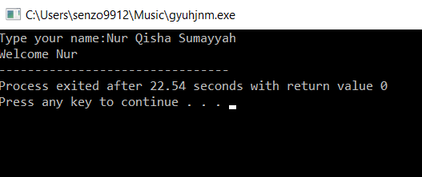

b)cin can only read 1 word and limited by whitespace, thus need to use getline

getline(cin,studentName);

5

a)state.length();

b)myBook.append(varStr);

c)myAddress.append(“aa”,5,2);

d)myWord.assign(“x”,3);

e)myString.assign(varStr,3,3);

f)mySentences.at(4);

g)movieTitle.find(varStr);

6)a) s1 assigned to s3, output:WIRA

b)s2 assigned to s3 with 4 character length and starts at 3, output:SONA

c)s1 will add to the end of s4 output:WIRA

d) s2 will add at the end of s2 with 3 character length and starts at character 3, output:

WIRASON

7)

a)swap is to swap 2 variable of string

string one(“apples”);

string two(“beans”);

cout<<one<<two<<endl;

one.swap(two);

cout<<one<<two<<endl;

b) it copy 1 string to other variable

string str1, str2;

strcpy(str1,str2);

c)it will clear the string

string str1=string.empty();

d)it gives the first found occurance

string s1(“ham is spam oh yeas I am!”);

cout<<s1.find(“am”)<<endl;

e)to insert new string in 1 variable

string line(“This is potato”);

line.replace(8,14,”peter”);

line.insert(8,”the amazing”);

cout<<line;

f)substr is to create a small string from bigger string

string s1("OMG i think i am preggy");

cout<<s1.substr(17,7) ;